*BARRIERS TO BARE HAND CONTACT*



Scoops



Chopsticks



Deli Papers

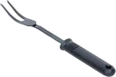

Forks and Ladles



Single

U

se

G

loves

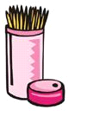

Toothpicks



Tongs

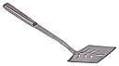

Spatulas

**Utensils to Prepare Ready To Eat Foods**

.

Draft submitted for approval: April 2010

**Thank you again for your efforts and focus on Food Safety and support of the Barriers to Bare Hand Contact.**

**Special thanks to the Conference for Food Protection Food Contact Utensil Barrier Usage Committee members:**

**2009-2010 Committee**

**Julie Albrecht, University of Nebraska-Lincoln**

**Anthony Carotenuto, Navy and Marine Corps Public Health Center**

**LeAnn Chuboff, SQFI**

**Sharon Ferguson, FDA**

**Andrew Harris, Division of Environmental Health, Summit County Health District**

**Stephen Posey, Brinker International**

**Jim Wagner, The Steritech Group, Inc.**

**Lisa Whitlock, FDA - Alternate**

**2007-2008 Committee**

**Michelle Motsinger**

**Janet Anderberg, Washington State Department of Health**

**Joseph Comello**

**Diane Benjamin, FDA**

**Jeannie Riess**

**Robert Joyce**

**Lacie Thrall, FoodHandler, Inc.**

**Doris Rittenmeyer, FoodHandler, Inc.**

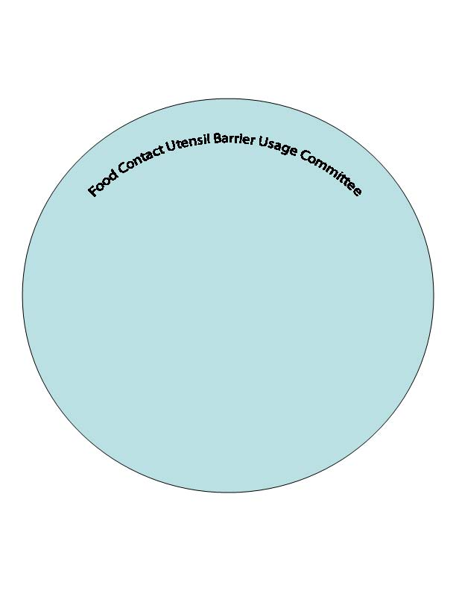

**Jane Griffith, WaWa, Inc.**

**Frank Ferko, US Foodservice**

**Linda McClurg, Dunkin Brands, Inc.**

**Dr. Esah Yip, Malaysian Rubber Export Council**

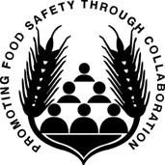

*Table of Contents*

**INTRODUCTION…….……………….…………………………………………………………****3**

**SECTION 1 – SINGLE USE GLOVES** **5**

**SECTION 2 – SCOOPS, SPOONS, AND LADLES** **8**

**SECTION 3 – SPATULAS** **10**

**SECTION 4 – TONGS** **11**

**SECTION 5 – FORKS** **12**

**SECTION 6 – DELI PAPERS** **13**

**SECTION 7 – CHOPSTICKS** **14**

**SECTION 8 – TOOTHPICKS** **15**

**FREQUENTLY ASKED QUESTIONS .** **17**

**APPENDIX/TOOLS** **19**

**REFERENCES…………………………………………………………………………………20PRESENTATION………………………………………………………………………………23**

*Introduction*

The Barriers to Bare Hand Contact Training Manual has been developed to be used as a teaching and training tool for consumers, industry, and regulatory to demonstrate the industry’s best practices regarding bare hand contact barriers and alternatives to bare hand contact.

A Power Point presentation is available at the end of this document.

#### 



*Barriers to Bare Hand Contact Reference Material*



**SECTION 1 – SINGLE USE GLOVES**



**Section 1.1 – Glove Information**

1. The correct use of glove barriers is important during food handling tasks. Single-use gloves can be an effective barrier against the transmission of microorganisms, such as bacteria & viruses, from fingertips or foods.
2. Handwashing is a primary barrier to cross contamination while barrier utensils & gloves are a secondary barrier.
3. Single-use gloves are defined as a “utensil” in the FDA Food Code.
4. Glove barriers work when handling any ready-to-eat (RTE) food while another utensil does not provide the hand dexterity for the task. (example: slicing carrots or celery). One glove may work on one hand with a utensil used by the other hand.

**Section 1.2 – When Should a Food Employee Use Single Use Gloves?**

1. If a food handler has a bandage, infection, cut, or sore on hands or arms, they must temporarily avoid direct bare hand contact during food handling duties.
2. When food employees wear artificial nails or fingernail polish, they must wear disposable gloves when handling food.
3. Glove use may be optional to handle raw meats, but can be used for preparation tasks such as breading/battering meats, poultry, seafood, or vegetables.

**Section 1.3 – Glove Barriers Must be Task Specific**

1. Use gloves for designated food tasks only. Disposable gloves are task-specific and should never be worn continuously.
2. Gloves designated for food use should not be used for non-food tasks, such as taking out the garbage, handling money, cleaning surfaces, etc.
3. Use vinyl, nitrile synthetic, or latex gloves when handling foods near a heat source cooking area, rather than poly (polyethylene) gloves, which are not resistant to heat.

**Section 1.4 – Avoid Cross Contamination by Washing Hands and Changing Gloves**

1. If someone handles raw meats, poultry, or seafood with gloves on, they must not touch RTE or cooked foods without washing hands and changing gloves.
2. Remove or change gloves when changing activity (for example from making sandwiches to making change) or whenever leaving the workstation. Hands must be washed before re-gloving.
3. Task-specific colored gloves are another option for cross contamination prevention.

**Section 1.5 – Glove Change Frequency**

1. Change gloves periodically and wash hands each time before changing gloves.
2. After handwashing, dry hands thoroughly before donning gloves to make them easier to slip on.
3. Base the frequency of glove changing on task changes.
4. Remove gloves if doing different tasks when not handling RTE foods.
5. Change gloves to handle a raw food or different raw species (for example raw chicken to raw beef).
6. Change gloves to handle another RTE food that might transfer a flavor or food allergen.
7. Wash hands and re-glove if a glove develops a hole or tear during usage.
8. Change gloves after sneezing, coughing, or touching hair or face.

**Section 1.6 – Four Common Glove Materials**

1. Polyethylene (Poly) Gloves
2. Latex Gloves
3. Vinyl Gloves
4. Nitrile Gloves

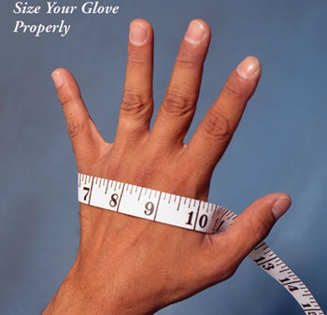

**Section 1.7 – Glove Size**

1. Glove size is important for safety and comfort.
2. Select the right size for hands— from small to extra large.
3. Poly, Vinyl, Latex, & Nitrile usually come in 4 or 5 sizes – Small, Medium, Large, X or XX-Large
4. Glove sizes are measured across the widest part of the palm as shown.

**Section 1.8 – Avoid Cross Contamination with Cut Resistant Gloves**

1. If wearing a cut-resistant glove to cut or handle raw or RTE food, wear a larger disposable glove over it to avoid cross-contamination of the reusable cut-resistant glove.
2. Wash, rinse & sanitize the cut-resistant glove between uses.

**Section 1.9 – Glove Removal**

1. To remove disposable gloves correctly, grasp at the cuff and peel them off inside-out.
2. DO NOT remove and re-use gloves OR re-wash single-use food contact gloves for multiple tasks.

**Section 1.10 – Selecting the Right Glove for the Right Job**

1. Consider specific tasks when determining the type of glove to be used.
2. Nitrile & Latex may be more durable for longer single tasks. Vinyl & Polyethylene may work better for shorter general food handling tasks. Be aware that some individuals may have allergen concerns with latex.
3. Polyethylene may work better for light duty tasks which involve high dexterity & durability.
4. Textured gloves may improve grip, tactile sensitivity or comfort.
5. Color-coding may help for cross-contamination prevention & visibility when handling foods.
6. Heat resistance may help around cooking equipment.
7. Cuff length extended (elbow length) can be considered depending on the tasks.
8. Dispensing stations should be located for easy quick access with close proximity to RTE food handling & handwashing.

**Section 1.11 – Powdered or Powder Free Glove Barriers**

1. Powder makes gloves easier to put on & absorbs perspiration, but some users prefer no powder.
2. Amount of powder (if used)

– *Powdered gloves* do not exceed 120 mg trace powder per glove (vinyl, nitrile, latex)

* Powder must be a Sterile Absorbable Dusting Powderd
* Acts as a donning lubricant
* Must be minimal
* No talc or unsterilized powders

– *Powder-free gloves* (vinyl, nitrile, latex)

* Contain no more than 2 mg trace powder per glove
* Some form-fit gloves are polyurethane coated or washed in chlorine to eliminate powder
* Poly gloves contain no powder

**Section 1.12 – Basic Poly or Cast Poly Gloves**

1. “Basic seamed poly” glove – known as “blown polyethylene” & can be white, opaque, or colored. Usually a loose fit. Less dexterity than form-fit gloves. Seamed on the edges.
2. “Cast poly” has a better fit & softer feel than basic blown poly. Easier to slip on &

sometimes textured for better grip.

1. A “Poly” glove is designed for light duty, short tasks. It is not designed for handling heat (approx. melt point 200°F(93°C)).
2. Elbow length gloves are for special light duty tasks requiring arm length reach or deep containers.

**Section 1.13 – Rapid Dispensing or Short Task Poly Gloves**

1. Loose fitting gloves are also designed in fingered glove or a mitt with unique dispensing systems to enable quick one-handed donning.
2. Applications may only use one glove for single tasks that require frequent glove changing in a fast-paced environment..
3. High Density Polyethylene (HDPE) which uses a different resin is more heat-resistant at 240°F(115°C) than Low Density Polyethylene at 200°F(93°C). However, it is not recommended for hot food tasks.

**SECTION 2 - SCOOPS, SPOONS, AND LADLES**

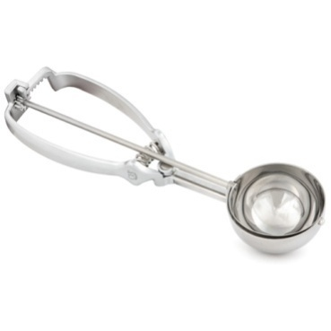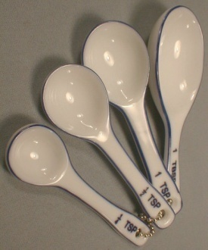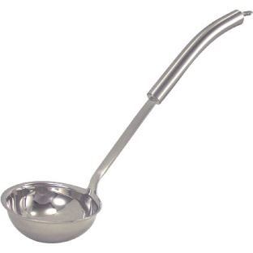

**Section 2.1 – When Should a Food Employee Use Scoops****, Spoons, and Ladles?**

1. Spoons, scoops and ladles are used by foodhandlers, servers, and customers when preparing, portioning, or serving liquid or solid foods.
2. The construction and design of the food contact surface should follow FDA Food Code requirements in section 4-201.11 and be durable and able to retain its characteristic qualities under normal conditions.
3. All utensils should be washed, rinsed, sanitized and air dried between uses and at least every 4 hours when being used.
4. When not in use, utensils must be stored in a manner to prevent bacterial growth such as in the food, in a clean and protected environment, under running water, or in a container at a minimum temperature of 135°F(57°C).
5. During pauses in food preparation or dispensing, food preparation and dispensing utensils shall be stored:

* In food with their handles above the top of the food and the container.
* On a clean portion of the food preparation table or cooking equipment that has been cleaned and sanitized.
* In running water with a water velocity sufficient to flush particles to the drain for moist foods such as potatoes or ice cream.
* In a washed and sanitized container of water, if the water is maintained at a temperature of at least 135°F (57°C).
* In a clean protected location if utensils (such as ice scoops) are used for non-potentially hazardous foods (Time/Temperature Control for Safety Food).

1. In-use utensils may not be stored in chemical sanitizer or ice.

**Section 2.2 – Using Scoops**

1. Scoops are available in many different sizes and are an ideal utensil for portion control.
2. When using a scoop with a release trigger, the release trigger should be prevented from touching the food. This prevents pathogens from the hand transferring to the food.
3. Scoops can be used with or without the use of other barriers. Scoops are a practical alternative to handling food with bare hands in many situations.

Scoops may be used as a stand alone tool or in conjunction with another barrier such as gloves.

**Section 2.3 – Using Spoons**

1. Spoons typically have no predetermined serving size or shape.
2. Spoons used for tasting must be washed, rinsed, and sanitized between uses. Disposable or single serving utensils can work well for this task.
3. Improper use of tasting spoons can lead to foodborne illness.
4. Spoons can be used with or without the use of other barriers. Spoons are a practical alternative to handling food with bare hands in many situations.

**Section 2.4 – Using Ladles**

1. Ladles are available in many different sizes and are an ideal utensil for portion control.
2. Ladles can be used with or without the use of other barriers. Ladles are a practical alternative to handling food with bare hands in many situations.
3. Ladles may be used as a stand alone tool or in conjunction with another barrier such as gloves.

**SECTION 3 – SPATULAS**

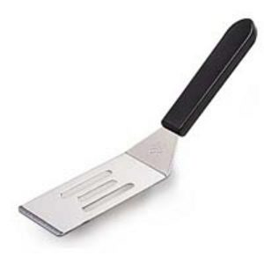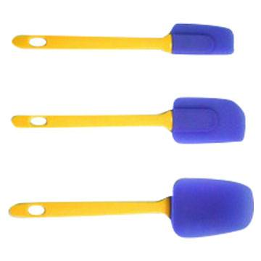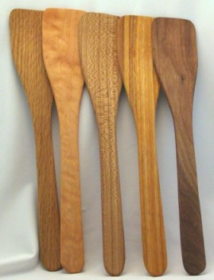

**Section 3.1 – When Should a Food Employee Use Spatulas?**

1. Spatulas are used to stir, scoop, spread, or lift food by foodhandlers, servers and customers.
2. The construction and design of the food contact surface should follow FDA Food Code requirements in section 4-201.11 and be durable and able to retain its characteristic qualities under normal conditions.
3. All utensils should be washed, rinsed, sanitized and air dried between uses and at least every 4 hours when being used.
4. When not in use, utensils must be stored in a manner to prevent bacterial growth such as in the food, in a clean and protected environment, under running water, or in a container at a minimum temperature of 135°F.
5. During pauses in food preparation or dispensing, food preparation and dispensing utensils shall be stored:

* In food with their handles above the top of the food and the container.
* On a clean portion of the food preparation table or cooking equipment that has been cleaned and sanitized.
* In running water with a water velocity sufficient to flush particles to the drain for moist foods such as potatoes or ice cream.
* In a washed and sanitized container of water, if the water is maintained at a temperature of at least 135°F (57°C).
* In a clean protected location if utensils (such as ice scoops) are used for non-potentially hazardous foods (Time/Temperature Control for Safety Food).

1. In-use utensils may not be stored in chemical sanitizer or ice.

**Section 3.2 – Using Spatulas**

1. Spatulas are available in generalized and highly adapted designs widely available for specific tasks.
2. Spatulas should be dedicated to a specific task.
3. Spatulas can be used with or without the use of other barriers. Spatulas are a practical alternative to handling food with bare hands in many situations.

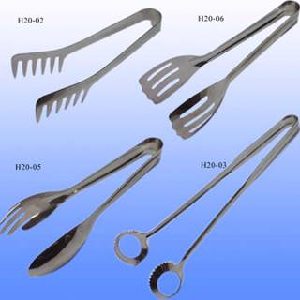

**SECTION 4 – TONGS**

**Section 4.1 – When Should a Food Employee Use Tongs?**

1. Tongs are used by foodhandlers and servers to grip or lift food, to move a food from one location to another, and to rotate food during cooking, especially during grilling.
2. The construction and design of the food contact surface should follow FDA Food Code requirements in section 4-201.11 and be durable and able to retain its characteristic qualities under normal conditions.
3. All utensils should be washed, rinsed, sanitized and air dried between uses and at least every 4 hours when being used.
4. When not in use, utensils must be stored in a manner to prevent bacterial growth such as in the food, in a clean and protected environment, under running water, or in a container at a minimum temperature of 135°F (57°C).
5. During pauses in food preparation or dispensing, food preparation and dispensing utensils shall be stored:

* In food with their handles above the top of the food and the container.
* On a clean portion of the food preparation table or cooking equipment that has been cleaned and sanitized.
* In running water with a water velocity sufficient to flush particles to the drain for moist foods such as potatoes or ice cream.
* In a washed and sanitized container of water, if the water is maintained at a temperature of at least 135°F (57°C).
* In a clean protected location if utensils (such as ice scoops) are used for non-potentially hazardous foods (Time/Temperature Control for Safety Food).

1. In-use utensils may not be stored in chemical sanitizer or ice.

**Section 4.2 - Using Tongs**

1. Tongs are a practical alternative to handling food with bare hands in many situations.
2. Tongs are available in generalized and highly adapted designs widely available for specific tasks.
3. Specific tongs are designed for picking up items such as sugar cubes, asparagus, shredded cheese, ice, salad, spaghetti, hamburgers, fish bones, melon balls, bagels, cooked crabs, garnishes and tea bags.
4. Tongs should be dedicated to a specific task.
5. Tongs can be used with or without the use of other barriers. Tongs are a practical alternative to handling food with bare hands in many situations.

**SECTION 5 – FORKS**

**Section 5.1 – When Should a Food Employee Use Forks?**

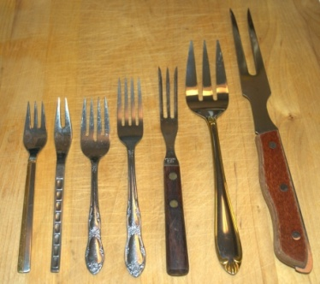

1. Forks are used by foodhandlers and servers to grip or lift food, to move a food from one location to another, to rotate food during preparation, and to hold or grip a food while cutting or carving.
2. The construction and design of the food contact surface should follow FDA Food Code requirements in section 4-201.11 and be durable and able to retain its characteristic qualities under normal conditions.
3. All utensils should be washed, rinsed, sanitized and air dried between uses and at least every 4 hours when being used.
4. When not in use, utensils must be stored in a manner to prevent bacterial growth such as in the food, in a clean and protected environment, under running water, or in a container at a minimum temperature of 135°F(57°C).
5. During pauses in food preparation or dispensing, food preparation and dispensing utensils shall be stored:

* In food with their handles above the top of the food and the container.
* On a clean portion of the food preparation table or cooking equipment that has been cleaned and sanitized.
* In running water with a water velocity sufficient to flush particles to the drain for moist foods such as potatoes or ice cream.
* In a washed and sanitized container of water, if the water is maintained at a temperature of at least 135°F (57°C).
* In a clean protected location if utensils such as ice scoops are used for non-potentially hazardous foods (Time/Temperature Control for Safety Food).

1. In-use utensils may not be stored in chemical sanitizer or ice.

**Section 5.2 - Using Forks**

1. Forks are a practical alternative to handling food with bare hands in many situations.
2. Forks should be dedicated to a specific task.
3. Forks which are designed and intended for single-use only must be discarded after each use.
4. Forks can be used with or without the use of other barriers. Forks are a practical alternative to handling food with bare hands in many situations.

**SECTION 6 – DELI PAPERS**

**Section 6.1 – When Should a Food Employee Use Deli and Bakery Wrap?**

1. Deli and Bakery Wrap are used by foodhandlers, servers/wait-staff, and customers to provide a sanitary barrier between the bare hand and food.

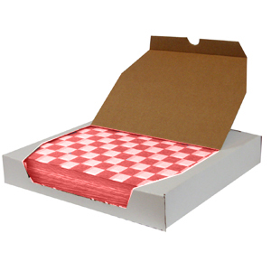

**Section 6.2 – Selecting Bakery or Deli Wrap**

1. Operators or purchasing agents must ensure all wrap components are in compliance with the FDA, Title 21, CFR 177.1520.
2. Deli wrap papers must be manufactured in accordance to Good Manufacturing Practices. Manufacturers of food contact wraps or sheets must demonstrate that all components are safe for use and do not leech components or toxic elements onto the food.
3. Deli wrap papers can be purchased in a variety of sheet sizes and packages from a foodservice supply vendor.
4. Wrap can be dry waxed or without wax. Dry wax will absorb some liquid and prevent the seeping of product liquid onto the hands. Wraps without wax are generally intended to be used for bakery products.
5. Dispensing packages must be well made to prevent contamination of the sheets from external debris and permit easy access to the sheet.
6. Food service operators should select wrap based on intended purpose.

**Section 6.3 – Using Deli and Bakery Wrap**

1. Sheets should be dispensed one at a time without tearing or contaminating the remaining sheets.
2. If sheets are used as the primary barrier, foodhandlers should discard used sheets immediately after use. Sheets should not be reused or remain with the food.
3. The dispensing container must be stored in a location to prevent cross contamination from other food or debris.

**SECTION 7 – CHOPSTICKS**

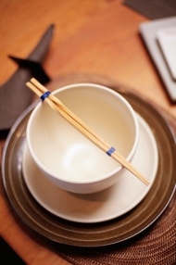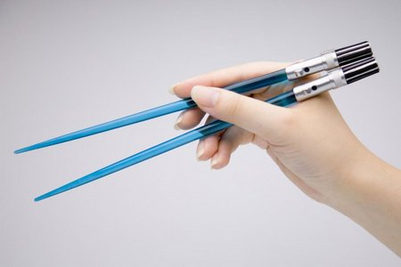

**Section 7.1 – When Should a Food Employee Use Chopsticks?**

1. Chopsticks are usually used by consumers for eating but foodhandlers may use chopsticks to move food from one location to another during preparation or service.
2. The construction and design of the food contact surface should follow FDA Food Code requirements in section 4-201.11 and be durable and able to retain its characteristic qualities under normal conditions.
3. All utensils should be washed, rinsed, sanitized and air dried between uses and at least every 4 hours when being used.
4. When not in use, utensils must be stored in a manner to prevent bacterial growth such as in the food, in a clean and protected environment, under running water, or in a container at a minimum temperature of 135°F(57°C).
5. During pauses in food preparation or dispensing, food preparation and dispensing utensils shall be stored:

* In food with their handles above the top of the food and the container.
* On a clean portion of the food preparation table or cooking equipment that has been cleaned and sanitized.
* In running water with a water velocity sufficient to flush particles to the drain for moist foods such as potatoes or ice cream.
* In a washed and sanitized container of water, if the water is maintained at a temperature of at least 135°F (57°C).
* In a clean protected location if utensils such as ice scoops are used for non-potentially hazardous foods (Time/Temperature Control for Safety Food).

1. In-use utensils may not be stored in chemical sanitizer or ice.

**Section 7.2 - Using Chopsticks**

1. Chopsticks may be an alternative to handling food with bare hands.
2. Chopsticks should be used for a specific task.
3. Chopsticks constructed to be a multi-use item must be washed, rinsed, sanitized, and air dried between different tasks.
4. Chopsticks designed and intended for single-use only must be discarded after each use.
5. Chopstickes may be used as a stand alone tool or in conjunction with another barrier such as gloves.

**SECTION 8 – TOOTHPICKS**

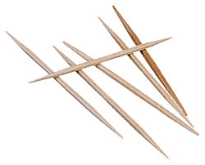

**Section 8.1 – When Should a Food Employee Use Toothpicks?**

1. Toothpicks are typically used by foodhandlers to prevent bare hand contact with RTE foods such as hors devours. However, toothpicks are also used to hold stacked/layered sandwiches or other items together and/or upright.
2. The construction and design of the food contact surface should follow FDA Food Code requirements in section 4-201.11 and be durable and able to retain its characteristic qualities under normal conditions.

**Section 8.2 - Using Toothpicks**

1. Toothpicks should be placed in food by staff prior to service, or presented and/or provided to consumer in a manner that will prevent possible contamination of the food contact portion of the toothpick, such as, upright in a small/slender glass or container.
2. Toothpicks are usually designed to be a single-use item and must be discarded after use.
3. If designed to be multi-use, toothpicks must be washed, rinsed, sanitized, air dried between tasks.

*Frequently Asked Questions*



Frequently Asked Questions:

1. **What is the purpose of this document?**

The Barriers to Bare Hand Contact Training Manual has been developed to be used as a teaching and training tool for consumers, industry, and regulators to demonstrate the industry’s best practices regarding bare hand contact barriers and alternatives to bare hand contact.

1. **How should I use this document?**

This document can be used to educate and inform consumers, industry, and regulators of best practices and options for use of bare hand contact barriers.

1. **Is this manual approved by health departments?**

This document has been developed in conjunction with the combined efforts of the Conference for Food Protection and input from federal, state, and local regulators, industry, academia, and consumers.

1. **Can I use information from this document in my presentations?**

This information can be used for educational purposes.

1. **Who should I contact if I have additional questions?**

Please contact your local health department or the Conference for Food Protection if you have additional questions.

1. **What if I have a question about a utensil that is not mentioned?**

This document is not meant to take the place of local regulatory requirements. Please consult your local health department for final requirements.

1. **Do utensils have to be certified?**

Please consult your local health department to determine utensil certification requirements.

# Appendix / Tools



# References

**2005 Model Food Code sections applicable to Barriers to Bare Hand Contact.**

**1-2 definitions**

1-201 – Applicability and Terms Defined

Ready-to-Eat Food

Utensil

**2-3 Personal Cleanliness**

2-301 Hands and Arms

2-301.11 Clean Condition Fingernails (refers to glove use)

2-301.12 Cleaning Procedure

2-301.14 When to Wash (refers to glove use)

2-301.15 Where to Wash

**3-3 Protection from Contamination After Receiving**

Preventing Contamination by Employees

3-301.11 Preventing Contamination from Hands (refers to deli tissue, spatulas, tongs, single-use gloves, or dispensing equipment

3-301.11(B) Preventing contamination from hands

**Preventing Contamination From Equipment, Utensils, and Linens**

3-304.11 – Food Contact with Equipment and Utensil

3-304.12 In-use utensils, between-use storage

3-304.15 – Gloves, Use Limitation

3-304.16 Using clean tableware for second portions and refills

3-502.12 Reduce oxygen packaging, criteria

3-502.12(B) (5) (a) (prohibits bare hand contact)

3-801.11 Pasteurized Foods, prohibited re-service and prohibited food

3-801.11(F) (3) (b) (prohibits bare hand contact)

**4-1 Materials for Construction and Repair**

Single-Service and Single Use

4-101.17 Wood, use limitations

4-102.11 Characteristics (single-service and single use

4-102.11 Characteristics

4-2 Design and Constructions

4-201.11 Equipment and utensils

4-205.10 Food Equipment, certification and classification

4-302.11 Utensils, consumer self-service

4-502.11 Single-service and single-use, required

4-502.13 Single-service and single-use, use limitations

4-6 Cleaning of Equipment and utensils

4-7 Sanitization of equipment and utensils

4-9 Protection of clean items

**4-9 Protection of Clean Items**

Storing

4-903.11 – Equipment, Utensils, Linens, and Single Service and Single Use Articles

Annex 3: Public Health Reasons/Administrative Guidelines:

Each Code Section will have back ground information or guidance in this Section of the Food Code.

# Presentation



Scoops



Chopsticks



Deli Papers



Forks and Ladles



Single

U

se

G

loves



Toothpicks



Tongs



Spatulas

**Utensils to Prepare Ready To Eat Foods**

